**We fought a great battle in all-media communication**

Source: [People's Forum Network](https://mp.weixin.qq.com/s/L9qvjBu62H4uTys0iLSzkQ)

Author: Lu Hong & Xu Chenjing

Editor: Wang Shuang

2024-01-27

https://politics.rmlt.com.cn/2024/0127/694077.shtml

**summary**

To commemorate the 130th anniversary of the birth of Comrade Mao Zedong, Global People magazine launched a 60-page cover story with the cover title "Mao Zedong, never old despite having traveled all over the mountains". The report is ideological, international, story-telling, and on-site, and it is pushed through all media, with hot spots and topics pre-set, making for a beautiful all-media communication campaign.

**Won a beautiful all-media communication battle**

——Global People magazine's report on commemorating the 130th anniversary of Comrade Mao Zedong's birth has aroused warm response

Lü Hong Xu Chenjing

On December 1, 2023, to commemorate the 130th anniversary of the birth of Comrade Mao Zedong, the People's Daily Global People magazine launched a 60-page cover story with a total of more than 60,000 words, with the cover title "Mao Zedong, never old despite having traveled all over the mountains." This is the most content-rich and earliest special report on the 130th anniversary of the birth of Comrade Mao Zedong in mainstream publications, which immediately aroused a warm response.

On the magazine sales side, this issue of the magazine has been sold out in all online and offline sales channels across the country. On December 20, 21, and 26, 2023, three consecutive reprints were made, and the total sales volume created the highest peak of magazine sales of "Global People" in the past three years. Many well-known self-media accounts and ordinary readers and fans have promoted this issue of the magazine on information and social platforms such as Weibo, Douyin, Toutiao, and Baidu Baijia, praising "Global People" for "doing things right in the way that the people most expect", and that it is "mainstream media that touches the pulse of the people's hearts" and "this publication can be called a 'tribute', and it is also worthy of respect for the editorial department's actions." By December 25, entries such as "Global People Issue 23" and "Global People Traveling Through the Mountains and Not Getting Old" have been defined as "hotly discussed" entries by Toutiao today, second only to the hot topics. Feedback from distributors in the e-commerce channels said that the market response this time can be described as "sensational". Global People is the first magazine brand in recent years that has sold out, reprinted, and sold out again entirely through spontaneous publicity and recommendations from fans and readers.

On the new media side, this group of reports created the best data for major theme reports of the Global People matrix in 2023. The Global People all-media matrix simultaneously launched 9 WeChat tweets, 3 long videos, and 4 short videos, and established 1 Weibo main topic #Mao Zedong's 130th birthday, stepping through the green mountains and not old#, with 9 Weibo topics under it. As of December 28, the total platform dissemination volume exceeded 50 million, of which the picture and text dissemination volume was 18.07 million; the video dissemination volume was 24.76 million, including the "explosive" video "The son of Mao Zedong's chief bodyguard Li Yinqiao: The chairman's special car never lets his family sit" and "The chairman especially likes to tease children"; the Weibo topic dissemination volume was 15.83 million. Each platform received a large number of high-quality fan messages, many of which were sincere, moving and full of emotion.

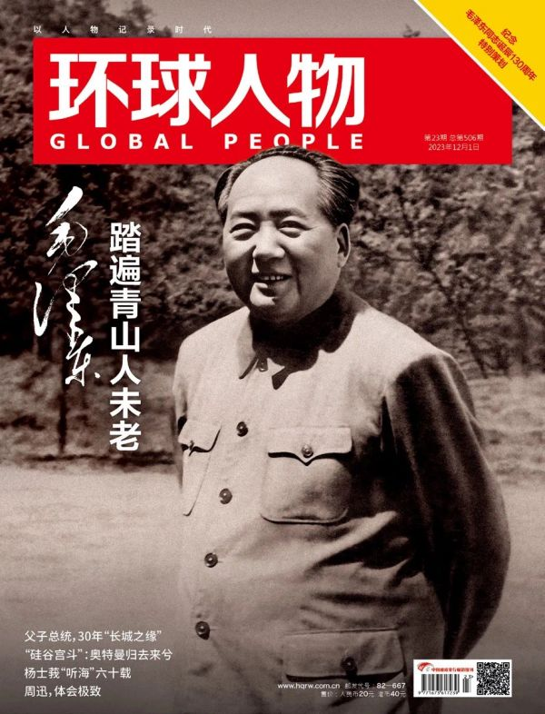

Cover of "Global People" magazine issue 506.

In recent years, Global People has gained an important experience in the practice of publicity and reporting, that is, we must dare to and be good at reporting on major topics. There are three main experiences that helped us do a good job in reporting on the 130th anniversary of the birth of Comrade Mao Zedong:

**First, adhere to the correct direction and guidance, conduct early analysis and judgment, carefully plan, and strictly review.**

The report commemorating the 130th anniversary of the birth of Comrade Mao Zedong is a very important and important report, which requires a high degree of political judgment, political understanding, and political execution to do a good job in this group of reports. Deputy Editor-in-Chief Fang Jiangshan, who is in charge of the People's Daily, attaches great importance to the report and has provided specific guidance on planning and manuscripts. In July 2023, the editor-in-chief and the deputy editor-in-chief in charge of the magazine conscientiously implemented the requirements, studied the relevant documents, thoroughly understood the spirit one by one, compared the requirements with the standards, and formed the judgment that "it is worth doing well and must be done well."

From August to September 2023, reporters and editors conducted in-depth and detailed communication with experts from relevant departments. Under the guidance of experts from authoritative departments, Global People had a more accurate grasp of the theme, scale and volume of the report commemorating the 130th anniversary of the birth of Comrade Mao Zedong, and determined the planning direction of "long-length, panoramic, and treasured".

After several rounds of communication with experts, Global People focused on the characteristics of the characters, adhered to the principle of keeping the truth and making innovations, and continuously improved the specific reporting plan. At the end of October, a reporting angle that was both profound and innovative was established: What was Mao Zedong like in the eyes of his contemporaries and in the eyes of people who knew Mao Zedong? And what were others like in Mao Zedong's eyes? Six sets of mirror-like relationships show Mao Zedong's true charm. How did Mao Zedong, who loved history, view the ancients? How do people today appreciate the inspiring words and magnificent poems left by Mao Zedong? Two sets of "one-way viewing" relationships present the past, present and future of Mao Zedong and China's excellent traditional culture.

After that, the reporters and editors devoted themselves to the work of interviewing, writing and compiling articles. It took a month to study the vast and rich party history materials. They also visited a large number of parties and their descendants who had intersections with Comrade Mao Zedong with the spirit of digging deep and never giving up. On November 23, 2023, after completing the internal "three reviews and three proofreadings", the entire set of all-media reports, including more than 60,000 words of manuscripts, dozens of historical pictures, 4 short videos, and 3 long videos, were all sent to relevant departments for review. After strict checks, they were published and pushed. The review experts affirmed the entire set of reports.

**Second, we should grasp our main responsibilities and focus on specialization and innovation, and go all out to produce high-quality reports that are ideological, international, narrative, and have a sense of presence.**

In the specific process of reporting and writing, Global People closely focused on the characteristics of the characters and was determined to achieve the unity of ideology and artistry. After the planning proposal was submitted, Deputy Editor-in-Chief Fang Jiangshan guided the addition of content on Mao Zedong's poems; after the text and graphic manuscripts were submitted, he guided attention to the accuracy of historical facts, documents, and texts, and carefully selected photos. After repeated polishing, this report has made new breakthroughs in four aspects, pushing the reporting level of Global People to a new height.

**First, the ideological content.** In the chapter on Comrade Mao Zedong and the masses, the idea that "the people, and only the people, are the driving force behind the creation of world history" is displayed; in the chapter on Comrade Mao Zedong and intellectuals, the idea that "we cannot build our country without intellectuals" is displayed; in the chapter on Comrade Mao Zedong and international figures, the idea that "the world is the same in terms of cold and heat" is displayed; in the chapter on Comrade Mao Zedong's comments on the ancients, the idea that "from Confucius to Sun Yat-sen, we should summarize and inherit this precious legacy" is displayed.

**Second, it is international.** The entire set of reports states that "Comrade Mao Zedong is a world great man who rose from the land of China in the 20th century" and "his vision is global. He dares to break through, make peace with, and help in a world of great changes. He has won a high reputation among people of different skin colors around the world and is admired by many people", which establishes a global color. In the section on Comrade Mao Zedong and international figures, five groups of people were carefully selected, including the US military observation group in Yan'an, the "comrade and brother" Vietnamese leader Ho Chi Minh, the ice-breaking Nixon, the young Che Guevara, and Kaunda in Africa, showing Mao Zedong in the world pattern and the world pattern influenced by Mao Zedong.

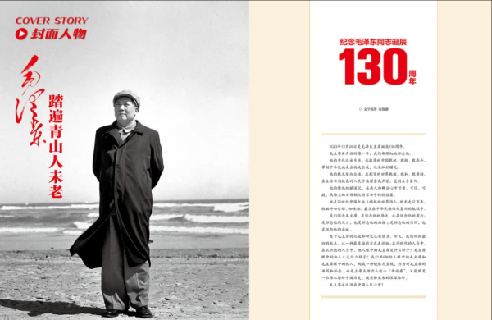

The interior page design for the cover story "Mao Zedong, never old despite having traveled all over the mountains" launched by Global People.

**The third is storytelling.** As a great leader of the Chinese people, many stories about Comrade Mao Zedong are well known to people; as a magazine that has published Mao Zedong on the cover more than 10 times, the reporters and editors of Global People are very familiar with the stories of Comrade Mao Zedong. How to tell Comrade Mao Zedong, a very familiar and representative figure, in a new way, with contemporary value and in an attractive way? The experience of Global People is that there is no shortcut, only to immerse yourself in reading and connect small stories in the voluminous party history materials. How much did Mao Zedong spend on books when he was studying in the First Normal School? Why did he go to "collect autumn wind"? How did the intellectuals who went to Yan'an describe Mao Zedong vividly and vividly? What are the details that the model workers who had dinner with Mao Zedong still can't forget? These vivid stories make the whole set of reports very readable.

**Fourth, the sense of presence.** One of the great difficulties in commemorating leaders is that the sense of history is more important than the sense of presence. Reporters and editors tried every means to "go to the scene". First, reporters went to Hunan, Jiangxi, Guizhou, Jiangsu and other places to find the historical scene; second, reporters visited Comrade Mao Zedong's relatives, friends, and people from all over the country who had come into contact with him in large numbers to find the oral scene, which brought about a sincere and strong emotional resonance. In terms of communication effect, it is precisely these interview videos full of a sense of presence, such as "The son of Mao Zedong's chief bodyguard Li Yinqiao: The Chairman never lets his family sit in his special car" and "The Chairman especially likes to tease children", which have become "explosive" with a dissemination volume of tens of millions.

**Third, we carried out deep integration, promoted the construction of all-media, carefully organized all-media push, embedded hot spots, preset topics, and fought a beautiful all-media communication battle.**

When submitting the entire set of reports for review, Global People took into account the effect of all-media communication, and "packaged and submitted for review" various forms of products such as manuscripts, pictures, long videos, and short videos, and simultaneously prepared a "divide and conquer" and "split and use" push plan for each platform. On the Douyin side, a combination of long and short videos was disseminated. On the WeChat side, excerpts of cover manuscripts were pushed for 7 consecutive days from December 20 to 26. On the Weibo side, when other media rushed to grab the topic words of the 130th anniversary in advance, Global People took a unique approach and established the topic word #Mao Zedong's 130th Anniversary of His Birth, Walking Through the Mountains and Not Old Again#, which was the same as the cover, forming a joint force of communication between the magazine and social media. Then, nine topics were added, such as #Why did young Mao Zedong walk more than 900 miles# #Mao Zedong used his own royalties to treat model workers to a meal# #Chairman Mao's close friendship with intellectuals# #How did Chairman Mao deal with the Kuomintang# #Chairman Mao's friendship with international people# #Li Yinqiao's son shares his fifteen years with Chairman Mao# #Chairman Mao prefers Li Bai or Du Fu# #How Chairman Mao is a father# #Wu Liandeng said Chairman Mao is like a family member to us#, etc., which were pushed one by one and achieved good communication effects. At present, the long-tail communication effect of these products and topics is still continuing, and the total communication volume is expected to exceed 60 million.

Standing at the starting point of 2024, the hot sales of the magazine "Mao Zedong, Still Young While Walking Through the Green Mountains" and the hot dissemination of all-media products have injected strong confidence into "Global People" to do a good job in publicity and reporting and all-media work in the new year. We will build on our victory, create outstanding achievements, and push content production and dissemination influence to a new level.

(The author Lv Hong is the editor-in-chief of Global People magazine, and Xu Chenjing is the director of the all-media center of Global People magazine) This article was published in News Front January 2024 (Part 2).